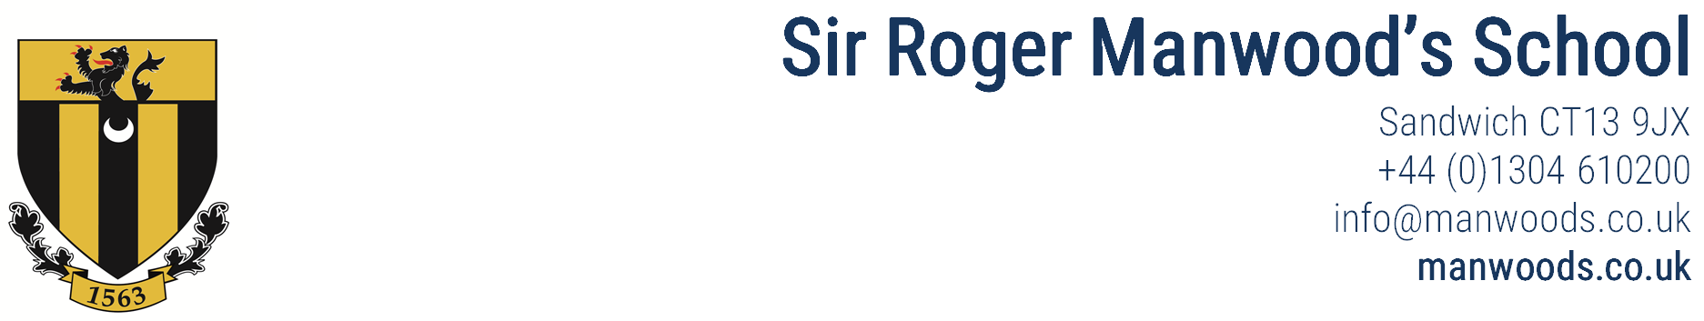

**Sir Roger Manwood’s School**

Sandwich CT13 9JX

+44 (0)1304 610200

[info@srms.kent.sch.uk](mailto:info@srms.kent.sch.uk)

[www.manwoods.co.uk](http://www.manwoods.co.uk)

**Deputy Head Teacher**

Full time, permanent contract, September 2025 start, L20 - L26

We are recruiting for a Deputy Headteacher, who will be the sole deputy at the school. This is a rare and exciting opportunity for an experienced senior leader to join a successful school that combines management freedom for effective leaders with secure central support that encourages collaboration for success.

We are looking for an exceptionally talented leader who will use their energy and vision to make a real impact; to support the achievement of outstanding outcomes for our students and staff, as well as ensuring that the school continues to develop its current standards and achievements – both academically and pastorally. The successful candidate will receive encouragement, support and guidance to develop their own career within the school.

The successful candidate will be an experienced, proactive and innovative school leader, with a clear strategic vision and the ability to support and develop staff and students.  As an outstanding practitioner, they will have a strong and consistent record of success across a number of schools and will have strong leadership skills with the ability to inspire and motivate the whole school community.

This post represents an opportunity to work with highly able young people in a supportive, well-equipped and forward-thinking school. We offer a friendly and inclusive working environment and the chance to be part of a fantastic team. SRMS is a great place to work and teach – it is a friendly, dynamic school where both staff and students thrive because they are highly valued.

We are preparing to embark on a new strategic development plan for the school, which values a rounded education that not only delivers outstanding academic outcomes but also encourages participation in the wider life of the school and development of skills for life, including leadership, collaboration and independence.

SRMS is a mixed grammar school that was graded Good in all categories by Ofsted in September 2022.

Please note the School does not offer sponsorship for overseas applicants who require it for employment in the UK.

Please note that all references will be taken up before interview as per our Safer Recruitment Policy

For further details and a downloadable application form please visit the vacancies section of the school website (www.manwoods.co.uk) or contact the Head’s PA, Mrs Robinson, on [head@srms.kent.sch.uk](mailto:head@srms.kent.sch.uk) or 01304 610206. Any offer of employment will be subject to receipt of two satisfactory references and a DBS Enhanced Disclosure.

CLOSING DATE: strictly noon on Monday 12th May

INTERVIEWS: the school reserves the right to interview as applications are received

SHORTLISTING: Only candidates who are shortlisted will be contacted

*Sir Roger Manwood’s School is committed to safeguarding and promoting the welfare of children and young people and expects all staff to share this commitment. Due to its Safer Recruitment Policy, the School will take up references before interview.*

**Engage…Explore…Excel…**